Chapter One

1.1 Problem Statement

Current Challenges in Financial Management

1. Lack of Financial Awareness
Many individuals struggle to understand their spending patterns and financial behavior. Without proper tracking mechanisms:
- Users often exceed their budgets unknowingly
- Difficulty in identifying unnecessary or excessive expenses
- No clear visibility into where money is being spent
- Inability to recognize spending trends over time
- Limited understanding of personal financial health

2. Manual Expense Tracking
Traditional methods of expense tracking present significant challenges:
- Time-consuming: Pen and paper or spreadsheet methods require manual data entry
- Error-prone: Human mistakes in recording, calculations, and categorization
- Data loss risk: Physical records can be lost or damaged
- Difficult analysis: Manual data makes trend analysis and reporting challenging
- No real-time access: Information is not immediately available when needed
- Lack of synchronization: Data cannot be accessed from multiple devices

3. Budget Management Difficulties
Effective budget management requires systematic approaches that are often missing:
- No standardized way to set and monitor budgets
- Inability to compare actual spending against planned budgets
- Lack of alerts when approaching or exceeding budget limits
- No category-wise budget allocation and tracking
- Difficulty in adjusting budgets mid-month based on actual spending
- No historical budget comparison for trend analysis

4. Lack of Financial Analytics
Users lack tools to visualize and analyze their financial data:
- No visual representation of spending data (charts, graphs)
- Difficulty in identifying spending trends and patterns
- No insights into category-wise spending distribution
- Limited ability to make informed financial decisions based on data
- No comparison of spending across different time periods
- Inability to forecast future expenses based on historical data

5. Accessibility Issues
Financial management tools are not universally accessible:
- Limited tools available in Arabic language
- No mobile-friendly expense tracking solutions
- Difficulty for non-technical users to manage finances
- Lack of user-friendly interfaces designed for general users
- No localization for cultural and regional preferences
- Expensive premium solutions creating barriers to entry

1.2 Project Objectives

Primary Objectives

1. Expense Recording and Management
Enable users to easily and efficiently record, organize, and manage their daily expenses:

- Easy Recording: Simple interface to record expenses with minimal effort
- Detailed Information: Capture amount, description, category, and date for each expense
- Multiple Categories: Support various expense categories (food, transport, education, shopping, utilities, entertainment, etc.)
- Edit Functionality: Modify recorded expenses to correct errors or update information
- Delete Functionality: Remove expenses when necessary
- Complete History: Maintain full expense history for reference and analysis
- Expense Details: Store additional information like merchant name, payment method, and notes

2. Budget Planning and Monitoring
Provide comprehensive budget management capabilities:

- Budget Setting: Allow users to set monthly budgets per category or overall
- Budget Tracking: Display real-time budget status and remaining balance
- Budget Alerts: Notify users when approaching or exceeding budget limits
- Spending Comparison: Compare actual spending against planned budgets
- Budget Adjustments: Allow mid-month budget modifications
- Budget History: Track budget changes and historical budget data
- Budget Analysis: Analyze budget effectiveness and spending patterns

3. Financial Analytics and Reporting
Provide visual insights and detailed reports:

- Visual Charts: Generate pie charts showing expense distribution by category
- Trend Analysis: Display monthly and yearly expense trends with bar charts
- Spending Patterns: Identify recurring expenses and spending habits
- Detailed Reports: Create comprehensive financial reports
- Data Export: Enable data export for external analysis
- Summary Statistics: Display key metrics and financial indicators
- Comparative Analysis: Compare spending across different periods

4. User Authentication and Security
Implement robust security measures:

- Secure Registration: Safe user account creation process
- Secure Login: Protected authentication mechanism
- Password Security: Implement password hashing and strength requirements
- Data Encryption: Protect sensitive user data
- Session Management: Secure session handling and timeout
- Data Privacy: Ensure user data confidentiality
- Role-Based Access: Implement different access levels for different user roles
- Audit Logging: Track user activities for security monitoring

5. User-Friendly Interface
Design an intuitive and accessible user experience:

- Intuitive Navigation: Easy-to-understand menu structure and navigation flow
- Responsive Design: Work seamlessly on desktop, tablet, and mobile devices
- Arabic Language Support: Full Arabic language interface with RTL layout
- Clear Dashboard: Comprehensive overview of financial status
- Accessible Components: UI elements that comply with accessibility standards
- Consistent Design: Unified visual design across all pages
- Quick Actions: Easy access to frequently used features

Secondary Objectives

6. Category Management
Enable users to organize expenses effectively:

- Custom Categories: Create custom expense categories
- Category Customization: Assign colors and icons to categories
- Predefined Categories: Provide default categories for quick setup
- Category Modification: Edit category details
- Category Deletion: Remove unused categories
- Category Hierarchy: Organize categories in hierarchical structure if needed

7. Data Filtering and Search
Provide powerful data exploration capabilities:

- Date Range Filtering: Filter expenses by specific date ranges
- Category Filtering: Search expenses by category
- Amount Range Filtering: Filter by minimum and maximum amounts
- Description Search: Search by expense description or keywords
- Advanced Sorting: Sort by various criteria (date, amount, category)
- Custom Reports: Generate reports based on filter combinations
- Saved Filters: Save frequently used filter combinations

8. Performance and Scalability
Ensure system reliability and growth capability:

- Fast Response Time: Application responds quickly to user actions
- Large Dataset Support: Handle thousands of transactions without performance degradation
- Efficient Queries: Optimize database queries for speed
- Frontend Optimization: Minimize load times and improve responsiveness
- Scalable Architecture: Design that supports future growth
- Caching Mechanisms: Implement caching for frequently accessed data
- Load Handling: Support concurrent users without service degradation

1.3 Scope of the Project

Included Features

Core Functionality
The application includes the following core features:

Feature | Description
User Registration | New user account creation with email verification
User Authentication | Secure login with session management
Expense CRUD | Create, read, update, delete expense records
Category Management | Create and manage expense categories
Budget Setting | Set monthly budgets per category or overall
Budget Tracking | Monitor spending against budgets
Dashboard | Summary view with key statistics
Expense Filtering | Filter by date, category, amount
Expense Search | Search by description or keywords
Visual Analytics | Pie charts and bar charts for data visualization
Monthly Reports | Generate monthly expense reports
Yearly Reports | Generate yearly expense reports
User Profile | Manage user account information
Data Export | Export data to CSV or PDF format

Technical Features
Feature | Description
Responsive Design | Works on desktop, tablet, and mobile devices
Arabic Language Support | Full Arabic interface with RTL layout
Exception Handling | Comprehensive error handling and logging
Database Backup | Automated backup mechanisms
Database Recovery | Data recovery procedures
Password Hashing | Secure password storage using bcrypt
Session Management | Secure session handling with timeout
Input Validation | Server-side validation of all inputs
Input Sanitization | Remove malicious characters from inputs
SQL Injection Prevention | Use prepared statements for all queries
XSS Protection | Prevent cross-site scripting attacks
CSRF Protection | Protect against cross-site request forgery

Project Boundaries

Technology Stack
Component | Technology
Backend | PHP 7.4 or higher
Database | MySQL 5.7 or higher
Frontend | HTML5, CSS3, JavaScript (ES6+)
Server | Apache

Supported Browsers
- Google Chrome 90 and above
- Mozilla Firefox 88 and above
- Apple Safari 14 and above
- Microsoft Edge 90 and above

Supported Languages
- Arabic (Primary language with RTL support)
- English (Secondary language)

Supported Devices
- Desktop computers (Windows, macOS, Linux)
- Tablets (iPad, Android tablets)
- Mobile phones (iOS, Android)

1.4 Project Significance

Business Significance

1. Market Opportunity
The project addresses a significant market opportunity:

- Growing Demand: Increasing demand for personal finance management tools globally
- Regional Growth: Increasing smartphone and internet penetration in Arabic-speaking regions
- Market Gap: Lack of Arabic-language financial management solutions
- Monetization Potential: Opportunity to generate revenue through premium features
- Business Expansion: Potential to expand to corporate and enterprise markets
- Competitive Advantage: First-mover advantage in Arabic market segment

2. Competitive Advantage
The application offers distinct competitive advantages:

- Arabic-First Design: First-class Arabic language support and localization
- User-Centric Interface: Designed specifically for Arabic-speaking users
- Open Source: Customizable and adaptable to specific needs
- Cost-Effective: No expensive licensing or subscription fees
- Accessibility: Free or low-cost solution for all users
- Community Support: Open-source community for continuous improvement

3. Revenue Potential
Multiple revenue streams are possible:

- Premium Subscriptions: Advanced features for paying users
- Corporate Licenses: Bulk licenses for businesses
- API Access: Charge for API access to third-party developers
- Data Analytics: Provide advanced analytics as a service
- Consulting Services: Offer customization and implementation services
- Training Programs: Provide training and support services

Social Significance

1. Financial Literacy
The project promotes financial awareness and literacy:

- Spending Awareness: Help users understand where their money goes
- Responsible Spending: Encourage conscious and responsible spending habits
- Financial Patterns: Help users identify their financial patterns and trends
- Budget Education: Teach users about budget management
- Financial Planning: Build foundation for long-term financial planning
- Economic Empowerment: Enable individuals to take control of their finances

2. Economic Empowerment
The application supports economic development:

- Personal Finance Control: Enable individuals to manage their finances independently
- Small Business Support: Help small business owners track expenses
- Spending Reduction: Help users identify and reduce unnecessary expenses
- Financial Independence: Promote financial autonomy
- Economic Stability: Support personal and family economic stability
- Wealth Building: Foundation for wealth accumulation and financial growth

3. Digital Inclusion
The project promotes digital access and inclusion:

- Technology Access: Provide technology access to Arabic-speaking populations
- Digital Divide Reduction: Reduce the digital divide through localization
- Technology Adoption: Promote technology adoption in developing regions
- Women Empowerment: Support women's financial independence
- Underbanked Population: Enable unbanked populations to manage finances
- Regional Development: Support economic development in Arabic-speaking regions

6. Conclusion
The Expense Tracker Web Application represents a comprehensive solution to financial management challenges faced by individuals and small businesses. By combining modern web technologies with user-centric design and comprehensive features, the application enables users to take control of their finances, understand their spending patterns, and make informed financial decisions.

The project's significance extends beyond individual users to broader social and economic impacts, including promoting financial literacy, supporting economic empowerment, and advancing digital inclusion in Arabic-speaking communities.

With its robust architecture, comprehensive documentation, and focus on security and user experience, the Expense Tracker Web Application is positioned to make a meaningful impact on personal finance management.

Chapter Three 3

3. Project Design
The development of the "Expense Tracker Web Application" system followed a structured design methodology to ensure the efficient and reliable achievement of its defined objectives. The design process was divided into sequential and interconnected stages, as follows:

3.1 System Architecture
The Expense Tracker Web Application employs a three-tier architecture pattern, separating concerns into distinct layers:

3.1.1 MVC Architecture Diagram
The system architecture follows the Model–View–Controller (MVC) design pattern and consists of the following components:
- View Layer (Presentation Layer)
  - Responsible for displaying the user interface
  - Built using:
    - HTML5
    - CSS3
    - JavaScript
    - Responsive Design
    - RTL Layout Support
  - Main pages include:
    - login.html
    - register.html
    - dashboard.html
    - Other interface pages
- Controller Layer
  - Handles user requests and application logic
  - Processes data between Views and Models
  - Main controllers include:
    - LoginController
    - ExpenseController
    - BudgetController
  - Additional components:
    - Validators
    - Services
    - Exception Handlers
- Model Layer
  - Responsible for database operations and data management
  - Handles:
    - Database Connections
    - Query Execution
    - Repositories
    - Data Processing
- Database Layer (MySQL)
  - Stores application data
  - Main tables:
    - users
    - categories
    - expenses
    - budgets
- Communication Flow
  - User interacts with the View
  - The Controller receives and processes requests
  - The Model communicates with the database
  - Results are returned back to the View for display

3.1.5 Technology Stack
Layer | Technology | Purpose
Frontend | HTML5, CSS3, JavaScript | User interface and interactivity
Backend | PHP 7.4+ | Server-side logic and processing
Database | MySQL 5.7+ | Data storage and management
Server | Apache/Nginx | Web server and request handling
Architecture | MVC | Separation of concerns
Security | bcrypt, HTTPS | Password hashing and encryption

3.2 Database Design
A relational database was designed in MySQL to serve as the central repository for all system information. The design includes a set of interconnected tables that ensure data integrity and minimize redundancy.
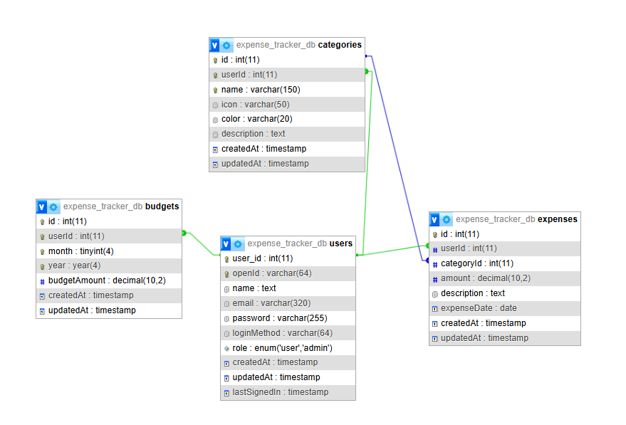

3.2.1 Database Overview
The Expense Tracker database consists of four main tables:

Table | Purpose | Records
users | Store user account information | User accounts
categories | Store expense categories | Expense categories
expenses | Store individual expense records | Daily expenses
budgets | Store monthly budget information | Monthly budgets

UML Diagrams

Use case :
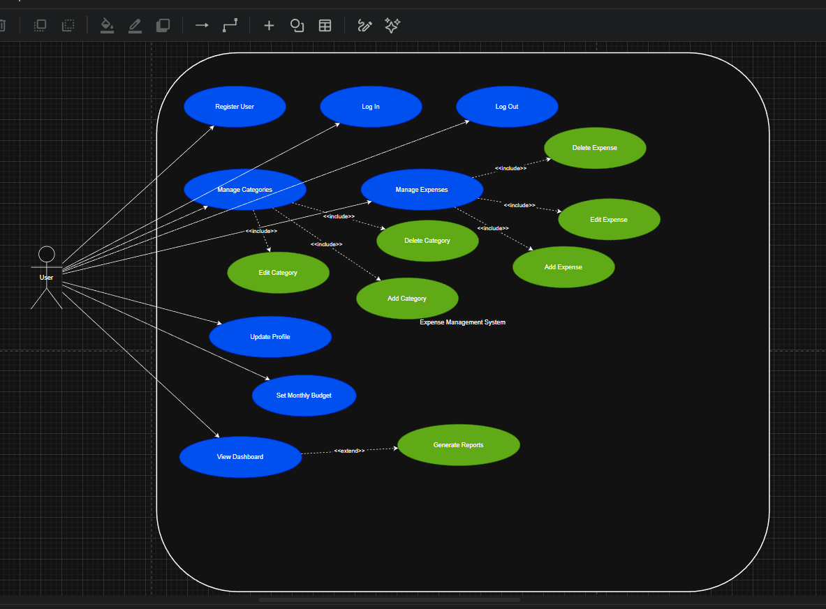

Activity Diagram :

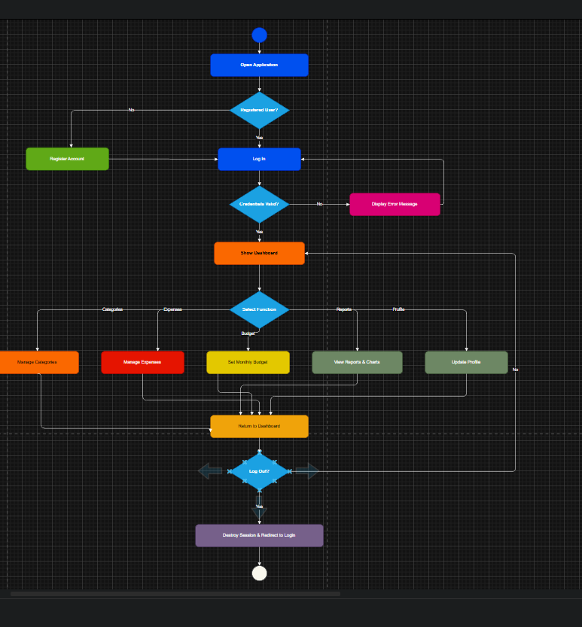

Sequence diagram

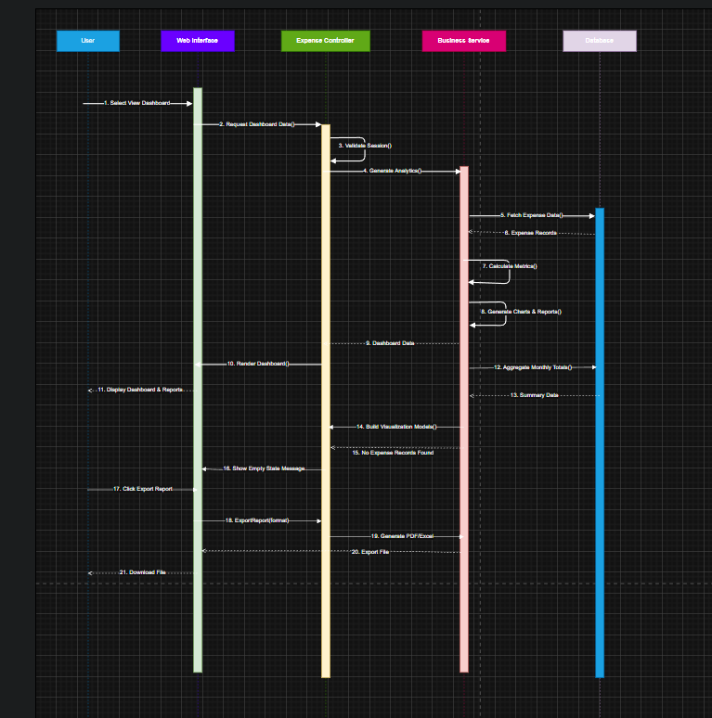
ERD

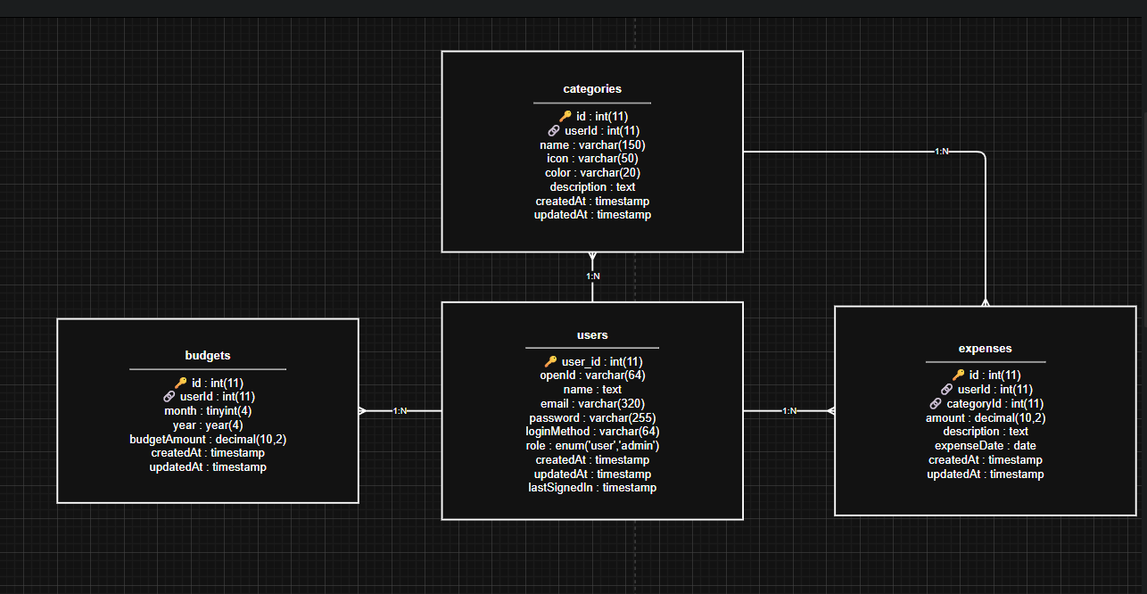

3.2.2 Table Specifications

1. Users Table
Purpose: Stores user account information and authentication details

Column | Data Type | Constraints | Description
id | INT | PRIMARY KEY, AUTO_INCREMENT | Unique user identifier
email | VARCHAR(255) | UNIQUE, NOT NULL | User email address
password | VARCHAR(255) | NOT NULL | Hashed password
first_name | VARCHAR(100) | NULL | User's first name
last_name | VARCHAR(100) | NULL | User's last name
phone | VARCHAR(20) | NULL | Contact phone number
date_of_birth | DATE | NULL | User's date of birth
created_at | TIMESTAMP | DEFAULT CURRENT_TIMESTAMP | Account creation timestamp
updated_at | TIMESTAMP | DEFAULT CURRENT_TIMESTAMP ON UPDATE | Last update timestamp
last_login | TIMESTAMP | NULL | Last login timestamp
is_active | BOOLEAN | DEFAULT TRUE | Account status flag
Character Set: UTF8MB4 COLLATE utf8mb4_unicode_ci

Key Relationships:
- One user can have many categories (1:N)
- One user can have many expenses (1:N)
- One user can have many budgets (1:N)

2. Categories Table
Purpose: Stores expense categories with customization options

Column | Data Type | Constraints | Description
id | INT | PRIMARY KEY, AUTO_INCREMENT | Unique category identifier
user_id | INT | NOT NULL, FOREIGN KEY | Reference to user (CASCADE DELETE)
name | VARCHAR(100) | NOT NULL, UNIQUE (with user_id) | Category name (Arabic support)
description | TEXT | NULL | Category description
color | VARCHAR(7) | NULL | Hex color code for UI display
icon | VARCHAR(50) | NULL | Icon identifier for UI display
is_default | BOOLEAN | DEFAULT FALSE | Flag for default categories
created_at | TIMESTAMP | DEFAULT CURRENT_TIMESTAMP | Creation timestamp
updated_at | TIMESTAMP | DEFAULT CURRENT_TIMESTAMP ON UPDATE | Last update timestamp
Character Set: UTF8MB4 COLLATE utf8mb4_unicode_ci

Unique Constraints:
- unique_user_category: Prevents duplicate category names per user

Key Relationships:
- Many categories belong to one user (N:1)
- One category can have many expenses (1:N)
- One category can have many budgets (1:N)

3. Expenses Table
Purpose: Stores individual expense records

Column | Data Type | Constraints | Description
id | INT | PRIMARY KEY, AUTO_INCREMENT | Unique expense identifier
user_id | INT | NOT NULL, FOREIGN KEY | Reference to user (CASCADE DELETE)
category_id | INT | NOT NULL, FOREIGN KEY | Reference to category (RESTRICT Delete)
amount | DECIMAL(10, 2) | NOT NULL | Expense amount in decimal format
description | TEXT | NULL | Expense description (Arabic support)
expense_date | DATE | NOT NULL | Date of expense
payment_method | VARCHAR(50) | NULL | Payment method (cash, card, etc.)
merchant_name | VARCHAR(255) | NULL | Name of merchant/vendor (Arabic support)
notes | TEXT | NULL | Additional notes (Arabic support)
receipt_path | VARCHAR(255) | NULL | Path to receipt image/document
created_at | TIMESTAMP | DEFAULT CURRENT_TIMESTAMP | Creation timestamp
updated_at | TIMESTAMP | DEFAULT CURRENT_TIMESTAMP ON UPDATE | Last update timestamp
Character Set: UTF8MB4 COLLATE utf8mb4_unicode_ci

Indexes:
- idx_user_date: (user_id, expense_date) - Optimizes date range queries
- idx_category: (category_id) - Optimizes category filtering
- idx_expense_date: (expense_date) - Optimizes date-based searches

Key Relationships:
- Many expenses belong to one user (N:1)
- Many expenses belong to one category (N:1)

4. Budgets Table
Purpose: Stores monthly budget information

Column | Data Type | Constraints | Description
id | INT | PRIMARY KEY, AUTO_INCREMENT | Unique budget identifier
user_id | INT | NOT NULL, FOREIGN KEY | Reference to user (CASCADE Delete)
category_id | INT | NULLABLE, FOREIGN KEY | Reference to category (SET NULL Delete)
month | INT | NOT NULL | Month number (1-12)
year | INT | NOT NULL | Year
budget_amount | DECIMAL(10, 2) | NOT NULL | Budget amount in decimal format
alert_threshold | DECIMAL(3, 2) | DEFAULT 0.80 | Alert threshold percentage (0.80 = 80%)
created_at | TIMESTAMP | DEFAULT CURRENT_TIMESTAMP | Creation timestamp
updated_at | TIMESTAMP | DEFAULT CURRENT_TIMESTAMP ON UPDATE | Last update timestamp
Character Set: UTF8MB4 COLLATE utf8mb4_unicode_ci

Unique Constraints:
- unique_user_month_category: Prevents duplicate budgets for same user/month/year/category

Key Relationships:
- Many budgets belong to one user (N:1)
- Many budgets belong to one category (N:1, nullable)

Database Relationships Summary

One-to-Many Relationships
Relationship | Type | Foreign Key | Cascade Rule | Description
Users → Categories | 1:N | categories.user_id → users.id | CASCADE | One user has many categories
Users → Expenses | 1:N | expenses.user_id → users.id | CASCADE | One user has many expenses
Users → Budgets | 1:N | budgets.user_id → users.id | CASCADE | One user has many budgets
Categories → Expenses | 1:N | expenses.category_id → categories.id | RESTRICT | One category has many expenses
Categories → Budgets | 1:N | budgets.category_id → categories.id | SET NULL | One category has many budgets

Data Types Reference
Data Type | Usage | Example
INT | Integer numbers | User ID, Month number
VARCHAR(n) | Variable-length strings | Email, names, descriptions
TEXT | Large text content | Notes, descriptions
DECIMAL(10, 2) | Decimal numbers for currency | Amount, budget
DATE | Date values | Expense date, birth date
TIMESTAMP | Date and time | Created at, updated at
BOOLEAN | True/False values | is_active, is_default

Constraints Reference
Constraint Type | Purpose | Example
PRIMARY KEY | Unique identifier for each row | id column in all tables
FOREIGN KEY | Link to another table | user_id references users(id)
UNIQUE | Prevent duplicate values | email in users table
NOT NULL | Require value in column | email, password
DEFAULT | Set default value | is_active DEFAULT TRUE
AUTO_INCREMENT | Auto-generate sequential numbers | id AUTO_INCREMENT
CASCADE | Delete related records | ON DELETE CASCADE
RESTRICT | Prevent deletion if related records exist | ON DELETE RESTRICT
SET NULL | Set to NULL if related record deleted | ON DELETE SET NULL

Character Set and Collation
Used: UTF8MB4 COLLATE utf8mb4_unicode_ci

Benefits:
- Full Unicode support including emojis
- Proper Arabic character storage and retrieval
- Supports all international characters
- Ensures correct sorting and comparison
- Maintains data integrity across different languages

Data Validation Rules

Users Table Validation
Column | Validation Rule
email | Must be unique, valid email format
password | Must be hashed using bcrypt
phone | Optional, valid phone format
date_of_birth | Optional, must be valid date
is_active | Boolean (0 or 1)

Categories Table Validation
Column | Validation Rule
name | Required, unique per user, max 100 characters
color | Optional, valid hex color code (7 characters)
icon | Optional, valid icon identifier
is_default | Boolean (0 or 1)

Expenses Table Validation
Column | Validation Rule
amount | Required, decimal with 2 decimal places, positive number
expense_date | Required, valid date, not in future
payment_method | Optional, valid payment method
merchant_name | Optional, max 255 characters
category_id | Required, must exist in categories table

Budgets Table Validation
Column | Validation Rule
month | Required, integer 1-12
year | Required, valid year
budget_amount | Required, decimal with 2 decimal places, positive number
alert_threshold | Optional, decimal 0-1 (0 to 100%)
category_id | Optional, must exist in categories table if provided

Table Statistics
Table | Columns | Primary Key | Foreign Keys | Unique Constraints | Indexes
users | 11 | id | 0 | 1 (email) | 1
categories | 9 | id | 1 | 1 (user_id, name) | 1
expenses | 12 | id | 2 | 0 | 4 (including PK)
budgets | 9 | id | 2 | 1 (user_id, month, year, category_id) | 1
Total | 41 | 4 | 5 | 3 | 7

3.4. Technical Specifications

3.1 System Requirements
Server Requirements:

- PHP 7.4 or higher
- MySQL 5.7 or higher
- Apache or Nginx web server
- 100MB disk space minimum
- 256MB RAM minimum

Client Requirements:

- Modern web browser (Chrome, Firefox, Safari, Edge)
- JavaScript enabled
- Cookies enabled for session management
- Internet connection

The Coding

Budget :
<?php
/**
* Budget Page
* صفحة الميزانية
*/

require_once 'includes/config.php';
require_once 'includes/auth.php';

requireLogin();
$userId = getCurrentUserId();
$pageTitle = 'الميزانية';
$errors = [];
$success = '';
$currentMonth = date('m');
$currentYear = date('Y');
$budgetAmount = 0;

if ($_SERVER['REQUEST_METHOD'] === 'POST' && isset($_POST['action']) && $_POST['action'] === 'set_budget') {
$budgetAmount = $_POST['budget_amount'] ?? '';

if (empty($budgetAmount) || !is_numeric($budgetAmount) || $budgetAmount < 0) {
$errors[] = 'يرجى إدخال مبلغ ميزانية صالح.';
}

if (empty($errors)) {
$stmt = $conn->prepare("SELECT id FROM budgets WHERE userId = ? AND month = ? AND year = ?");
$stmt->bind_param('iii', $userId, $currentMonth, $currentYear);
$stmt->execute();
$result = $stmt->get_result();

if ($result->num_rows > 0) {
$budgetRow = $result->fetch_assoc();
$stmt->close();
$stmt = $conn->prepare("UPDATE budgets SET budgetAmount = ?, updatedAt = NOW() WHERE id = ?");
$stmt->bind_param('di', $budgetAmount, $budgetRow['id']);
} else {
$stmt->close();
$stmt = $conn->prepare("INSERT INTO budgets (userId, month, year, budgetAmount, createdAt, updatedAt) VALUES (?, ?, ?, ?, NOW(), NOW())");
$stmt->bind_param('iiid', $userId, $currentMonth, $currentYear, $budgetAmount);
}

if ($stmt->execute()) {
$success = 'تم حفظ الميزانية لهذا الشهر بنجاح.';
} else {
$errors[] = 'حدث خطأ أثناء حفظ الميزانية. حاول مرة أخرى.';
}
$stmt->close();
}
}

Categories.php

<?php
/**
* Categories Page
* صفحة التصنيفات
*/

require_once 'includes/config.php';
require_once 'includes/auth.php';

requireLogin();
$userId = getCurrentUserId();
$pageTitle = 'التصنيفات';
$errors = [];
$success = '';

if ($_SERVER['REQUEST_METHOD'] === 'POST' && isset($_POST['action']) && $_POST['action'] === 'add_category') {
$name = sanitize($_POST['name'] ?? '');
$icon = sanitize($_POST['icon'] ?? '');
$color = sanitize($_POST['color'] ?? '#2563eb');

if (empty($name)) {
$errors[] = 'يرجى إدخال اسم التصنيف.';
}

if (empty($errors)) {
$stmt = $conn->prepare("INSERT INTO categories (userId, name, icon, color, createdAt, updatedAt) VALUES (?, ?, ?, ?, NOW(), NOW())");
$stmt->bind_param('isss', $userId, $name, $icon, $color);

if ($stmt->execute()) {
$success = 'تم إضافة التصنيف بنجاح.';
} else {
$errors[] = 'فشل إضافة التصنيف. قد يكون الاسم موجوداً بالفعل.';
}

$stmt->close();
}
}

if (isset($_GET['delete']) && is_numeric($_GET['delete'])) {
$categoryId = (int) $_GET['delete'];
$stmt = $conn->prepare("DELETE FROM categories WHERE id = ? AND userId = ?");
$stmt->bind_param('ii', $categoryId, $userId);
if ($stmt->execute()) {
$success = 'تم حذف التصنيف بنجاح.';
} else {
$errors[] = 'حدث خطأ أثناء حذف التصنيف. تأكد من عدم وجود مصروفات مرتبطة به.';
}
$stmt->close();
}

dashboard.php

<?php
/**
* Dashboard Page
* صفحة لوحة التحكم
*/

require_once 'includes/header.php';

// Require login
requireLogin();

$userId = getCurrentUserId();

// Get current month and year
$currentMonth = date('m');
$currentYear = date('Y');

// Get total expenses for current month
$stmt = $conn->prepare("
SELECT COALESCE(SUM(amount), 0) AS total
FROM expenses
WHERE userId = ?
AND MONTH(expenseDate) = ?
AND YEAR(expenseDate) = ?
");
$stmt->bind_param("iii", $userId, $currentMonth, $currentYear);
$stmt->execute();
$monthlyTotal = $stmt->get_result()->fetch_assoc()['total'];

// Get budget for current month
$stmt = $conn->prepare("
SELECT budgetAmount
FROM budgets
WHERE userId = ?
AND month = ?
AND year = ?
");
$stmt->bind_param("iii", $userId, $currentMonth, $currentYear);
$stmt->execute();
$budgetResult = $stmt->get_result();
$budget = $budgetResult->num_rows > 0 ? $budgetResult->fetch_assoc()['budgetAmount'] : 0;

// Get remaining budget
$remaining = $budget - $monthlyTotal;

// Get total expenses (all time)
$stmt = $conn->prepare("SELECT COALESCE(SUM(amount), 0) AS total FROM expenses WHERE userId = ?");
$stmt->bind_param("i", $userId);
$stmt->execute();
$totalExpenses = $stmt->get_result()->fetch_assoc()['total'];

$stmt = $conn->prepare("
SELECT
c.name,
c.color,
COALESCE(SUM(e.amount), 0) AS total
FROM categories c
LEFT JOIN expenses e ON c.id = e.categoryId
AND e.userId = ?
AND MONTH(e.expenseDate) = ?
AND YEAR(e.expenseDate) = ?
WHERE c.userId = ?
GROUP BY c.id, c.name, c.color
ORDER BY total DESC
");
$stmt->bind_param("iiii", $userId, $currentMonth, $currentYear, $userId);
$stmt->execute();
$categoryExpenses = $stmt->get_result();

// Get recent expenses
$stmt = $conn->prepare("
SELECT
e.id,
e.amount,
e.description,
e.expenseDate,
c.name AS category_name,
c.color
FROM expenses e
JOIN categories c ON e.categoryId = c.id
WHERE e.userId = ?
ORDER BY e.expenseDate DESC
LIMIT 5
");
$stmt->bind_param("i", $userId);
$stmt->execute();
$recentExpenses = $stmt->get_result();

$pageTitle = 'لوحة التحكم';
?>

<div class="container">
<!-- Hero Section -->
<section class="hero">
<div class="hero-card">
<div class="hero-grid">
<div>
<h2>مرحباً، <?php echo htmlspecialchars(getUserName()); ?></h2>
<p>إليك ملخص نفقاتك الشهرية والميزانية المتبقية. يمكنك إدارة مصروفاتك وتتبع إنفاقك بسهولة.</p>
<div class="hero-badges">
<a href="expenses.php" class="btn btn-primary">إضافة مصروف</a>
<a href="budget.php" class="btn btn-secondary">تعديل الميزانية</a>
</div>
</div>
<div class="hero-panel">
<div class="mini-card">
<div>
<strong><?php echo number_format($monthlyTotal, 2); ?> ر.س</strong>
<span>إجمالي هذا الشهر</span>
</div>
</div>
<div class="mini-card">
<div>
<strong><?php echo number_format($budget, 2); ?> ر.س</strong>
<span>الميزانية المخطط لها</span>
</div>
</div>
<div class="mini-card">
<div>
<strong><?php echo number_format(max(0, $remaining), 2); ?> ر.س</strong>
<span><?php echo $remaining >= 0 ? 'المتبقي' : 'تجاوز الميزانية'; ?></span>
</div>
</div>
</div>
</div>
</div>
</section>

Expenses.php

<?php
/**
* Expenses Page
* صفحة المصروفات
*/

require_once 'includes/config.php';
require_once 'includes/auth.php';

requireLogin();
$userId = getCurrentUserId();
$pageTitle = 'المصروفات';
$errors = [];
$success = '';

if ($_SERVER['REQUEST_METHOD'] === 'POST' && isset($_POST['action']) && $_POST['action'] === 'add_expense') {
$categoryId = $_POST['category_id'] ?? '';
$amount = $_POST['amount'] ?? '';
$description = sanitize($_POST['description'] ?? '');
$expenseDate = $_POST['expense_date'] ?? date('Y-m-d');

if (empty($categoryId) || !is_numeric($categoryId)) {
$errors[] = 'يرجى اختيار تصنيف صالح.';
}

if (empty($amount) || !is_numeric($amount) || $amount <= 0) {
$errors[] = 'يرجى إدخال مبلغ صالح أكبر من صفر.';
}

if (empty($expenseDate)) {
$errors[] = 'يرجى تحديد تاريخ المصروف.';
}

if (empty($errors)) {
$stmt = $conn->prepare("INSERT INTO expenses (userId, categoryId, amount, description, expenseDate, createdAt, updatedAt) VALUES (?, ?, ?, ?, ?, NOW(), NOW())");
$stmt->bind_param('iisss', $userId, $categoryId, $amount, $description, $expenseDate);

if ($stmt->execute()) {
$success = 'تم إضافة المصروف بنجاح.';
} else {
$errors[] = 'حدث خطأ أثناء حفظ المصروف. يرجى المحاولة لاحقاً.';
}

$stmt->close();
}
}

if (isset($_GET['delete']) && is_numeric($_GET['delete'])) {
$expenseId = (int) $_GET['delete'];
$stmt = $conn->prepare("DELETE FROM expenses WHERE id = ? AND userId = ?");
$stmt->bind_param('ii', $expenseId, $userId);
if ($stmt->execute()) {
$success = 'تم حذف المصروف بنجاح.';
} else {
$errors[] = 'فشل حذف المصروف. تأكد من صحة البيانات ثم أعد المحاولة.';
}
$stmt->close();
}

Login.php
<?php
/**
* Login Page
* صفحة تسجيل الدخول
*/

require_once 'includes/config.php';
require_once 'includes/auth.php';
require_once 'controllers/LoginController.php';

// If already logged in, redirect to dashboard
requireLogout();

// Initialize controller
$controller = new LoginController($conn);

// Handle login form submission
$controller->handleLogin();

// Load and render view
ob_start();
include 'views/login.html';
$content = ob_get_clean();

// Output content
echo $content;
?>

Logout.php
<?php
/**
* Logout Page
* صفحة تسجيل الخروج
*/

require_once 'includes/config.php';
require_once 'includes/auth.php';

// Require login first
requireLogin();

// Destroy session
session_destroy();

// Redirect to login page
header("Location: " . SITE_URL . "/login.php?logout=1");
exit;
?>

Profile.php

<?php
/**
* Profile Page
* صفحة الملف الشخصي
*/

require_once 'includes/header.php';

// Require login
requireLogin();

$user = getCurrentUser();

$pageTitle = 'الملف الشخصي';
?>

<div class="container">
<section class="section">
<div class="section-head">
<h3>الملف الشخصي</h3>
<p>معاينة معلومات حسابك وتفاصيل المستخدم.</p>
</div>

<div class="card">
<div class="profile-grid">
<div class="profile-card">
<h4>معلومات المستخدم</h4>
<dl>
<dt>الاسم</dt>
<dd><?php echo htmlspecialchars($user['name'] ?? '---'); ?></dd>

<dt>البريد الإلكتروني</dt>
<dd><?php echo htmlspecialchars($user['email'] ?? '---'); ?></dd>

<dt>الدور</dt>
<dd><?php echo htmlspecialchars($user['role'] ?? 'المستخدم'); ?></dd>
</dl>
</div>

<div class="profile-card">
<h4>إعدادات الحساب</h4>
<p>يمكنك تحديث بياناتك أو تغيير كلمة المرور من هنا عندما تكون هذه الميزة متاحة.</p>
<div class="profile-actions">
<a href="<?php echo SITE_URL; ?>/dashboard.php" class="btn btn-secondary">العودة للوحة التحكم</a>
<a href="<?php echo SITE_URL; ?>/logout.php" class="btn btn-danger" onclick="return confirm('هل تريد تسجيل الخروج؟')">تسجيل الخروج</a>
</div>
</div>
</div>
</div>
</section>
</div>

<?php require_once 'includes/footer.php';

Register.php

<?php
/**
* Register Page
* صفحة التسجيل
*/

require_once 'includes/config.php';
require_once 'includes/auth.php';
require_once 'controllers/RegisterController.php';

// If already logged in, redirect to dashboard
requireLogout();

// Initialize controller
$controller = new RegisterController($conn);

// Handle registration form submission
$controller->handleRegister();

// Load and render view
ob_start();
include 'views/register.html';
$content = ob_get_clean();

// Output content
echo $content;
?>

Reports.php

<?php
/**
* Reports Page
* صفحة التقارير
*/

require_once 'includes/config.php';
require_once 'includes/auth.php';

requireLogin();
$userId = getCurrentUserId();
$pageTitle = 'التقارير';
$errors = [];
$currentMonth = date('m');
$currentYear = date('Y');

$monthlyExpense = 0;
$totalExpense = 0;
$budgetAmount = 0;
$categorySummary = [];
$monthlySummary = [];

$stmt = $conn->prepare("SELECT COALESCE(SUM(amount), 0) AS total FROM expenses WHERE userId = ? AND MONTH(expenseDate) = ? AND YEAR(expenseDate) = ?");
$stmt->bind_param('iii', $userId, $currentMonth, $currentYear);
$stmt->execute();
$result = $stmt->get_result();
if ($row = $result->fetch_assoc()) {
$monthlyExpense = $row['total'];
}
$stmt->close();

$stmt = $conn->prepare("SELECT COALESCE(SUM(amount), 0) AS total FROM expenses WHERE userId = ?");
$stmt->bind_param('i', $userId);
$stmt->execute();
$result = $stmt->get_result();
if ($row = $result->fetch_assoc()) {
$totalExpense = $row['total'];
}
$stmt->close();

$stmt = $conn->prepare("SELECT budgetAmount FROM budgets WHERE userId = ? AND month = ? AND year = ?");
$stmt->bind_param('iii', $userId, $currentMonth, $currentYear);
$stmt->execute();
$result = $stmt->get_result();
if ($row = $result->fetch_assoc()) {
$budgetAmount = $row['budgetAmount'];
}
$stmt->close();

$stmt = $conn->prepare("SELECT c.name, COALESCE(SUM(e.amount), 0) AS total FROM categories c LEFT JOIN expenses e ON c.id = e.categoryId AND e.userId = ? AND MONTH(e.expenseDate) = ? AND YEAR(e.expenseDate) = ? WHERE c.userId = ? GROUP BY c.id, c.name ORDER BY total DESC");
$stmt->bind_param('iiii', $userId, $currentMonth, $currentYear, $userId);
$stmt->execute();
$result = $stmt->get_result();
while ($row = $result->fetch_assoc()) {
$categorySummary[] = $row;
}
$stmt->close();

7.2 Data Flow
User Registration Flow:

- User submits registration form
- RegisterController validates input
- Controller checks for duplicate email
- Controller hashes password
- Controller inserts user into database
- View displays success or error message

Expense Recording Flow:

- User submits expense form
- ExpenseController validates input
- Controller verifies user ownership
- Controller inserts expense into database
- Controller updates budget tracking
- View displays success message and updated data

Dashboard Display Flow:

- User requests dashboard
- DashboardController queries database
- Controller calculates summary statistics
- Controller retrieves recent expenses
- Controller calculates category breakdown
- View displays dashboard with all information

7. Deployment and Maintenance

7.1 Deployment Checklist
- ☐Set environment to production
- Disable debug mode
- Update database credentials
- Configure HTTPS/SSL
- Set proper file permissions
- Configure error logging
- Set up database backups
- Configure email notifications
- Test all functionality
- Monitor error logs

7.2 Maintenance Tasks
Regular Tasks:

- Monitor error logs daily
- Check database performance
- Review security logs
- Backup database weekly
- Update dependencies monthly
- Test backup recovery procedures

Periodic Tasks:

- Security audits quarterly
- Performance optimization
- Database optimization
- Code review and refactoring
- Documentation updates

8. Conclusion
The Expense Tracker Web Application represents a comprehensive solution to financial management challenges faced by individuals and small businesses. By combining modern web technologies with user-centric design and comprehensive features, the application enables users to take control of their finances, understand their spending patterns, and make informed financial decisions.

The project's significance extends beyond individual users to broader social and economic impacts, including promoting financial literacy, supporting economic empowerment, and advancing digital inclusion in Arabic-speaking communities.

Chapter Foure 4

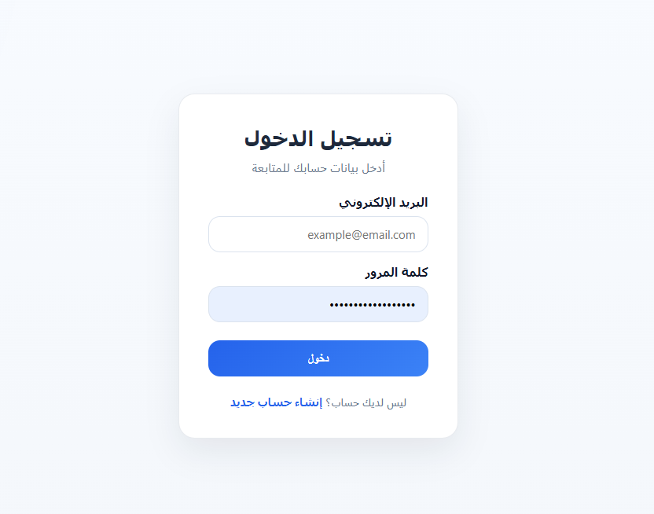

Dashboard Page :

